Suggested Preoperative Testing Decision Aid for Low-Risk Surgeries
*American Society of Anesthesiologist (ASA) Physical Status Classification System:
ASA Class I: Normal healthy patient. Non-smoking, no or minimal alcohol use, no acute or chronic disease, normal BMI.
ASA Class II: Mild systemic disease without substantive functional limitations. Current smoker, obesity (30<BMI<40), well-controlled DM/HTN, mild lung disease.
ASA Class III: Severe Systemic disease with substantive functional limitations, poorly controlled DM/HTN, COPD, morbid obesity (BMI ≥ 40), active hepatitis, alcohol dependence or abuse, pacemaker, moderate reduced EF, ESRD on dialysis, prior MI, CVA, TIA, or CAD/stents > 3 months ago

**May consider EKG if none are available within the past ~6 months
***Except recent (3-6 months) potassium if on a diuretic
All recommendations in this document pertain to non-pregnant, adult patients undergoing low-risk procedures. They do not replace clinical judgment and are intended as guidance only.

Suggested Preoperative Tests for Patients Undergoing Low-Risk Surgery Who Are ASA III or Above

This chart does not replace clinical judgment and is intended as guidance only.

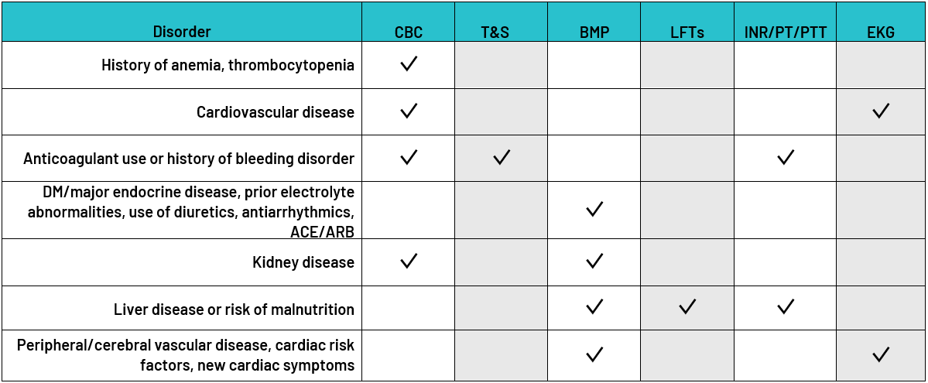
CBC: Complete blood count
T&S: Type and screen
BMP: Basic metabolic panel
ACE: Angiotensin-converting enzyme inhibitors
ARB: Angiotensin receptor blocker
LFTs: Liver function tests
INR: International normalized ratio
PT: Prothrombin time
PTT: Partial thromboplastic time
EKG: Electrocardiogram

References:
- Mocon A, McRitchie D, Tharani A. Drop the Pre-Op: A toolkit for reducing unnecessary visits and investigations in pre-operative clinics. Ontario, CA. 2019.
- Chow, W. B., Rosenthal, R. A., Merkow, R. P., Ko, C. Y., & Esnaola, N. F. (2012). Optimal preoperative assessment of the geriatric surgical patient: a best practices guideline from the American College of Surgeons National Surgical Quality Improvement Program and the American Geriatrics Society. Journal of the American College of Surgeons, 215(4), 453-466.
- National Guideline Centre (UK). Preoperative Tests (Update): Routine Preoperative Tests for Elective Surgery. London: National Institute for Health and Care Excellence (NICE); 2016 Apr. (NICE Guideline, No. 45.) Acknowledgements.
- Practice Advisory for Preanesthesia Evaluation: An Updated Report by the American Society of Anesthesiologists Task Force on Preanesthesia Evaluation. Anesthesiology 2012; 116:522–538 doi: https://doi.org/10.1097/ALN.0b013e31823c1067

